**CHAPTER I**

**INTRODUCTION**

**Chapter-1**

**Introduction**

This chapter gives overall introduction of proposed system. It deals with the information about the background, relevance, objectives, applications, advantages of the project undertaken.

**1.1 Background:**

Internet is becoming more widespread, and hence the possibility of communication with embedded systems for configuration, reprogramming or control in real time is easily manageable. For this, the embedded system needs a physical communication port with the network. This system presents the design and implementation of such Ethernet interface for Raspberry pi 2. A smart image processing web camera device is used to capture the image of the job. The camera can process, compress and store digital images, and zoom to a captured image using a digital image-capturing component therein. Today’s Industries mainly depend upon the precision and correctness of the product. It is efficient to detect and correct faults before the final production happens. Job measurement technique helps us to measure the dimensions of job and fault detection method detects the faults in the job. This process of detection and correction of faults before manufacturing is also called as ‘Burn –In’ processes. This process is more time saving, reduces complexity and cost of the product.

The measurement technique relates to a camera capable of performing digital image processing and also automatically analysing motion image and tracks the captured image automatically to monitor an area and provide clear images required at a later time. Measurement of dimension from the image is bit challenging. This project has been designed to determine faults in the job dimensions compared to master dimensions, that is, length and breadth and at the same time display the respective values. [6]

**1.2 Relevance:**

The Raspberry Pi platform originally intended for educational purposes has become famous immediately after its introduction in 2012. The next-generation Raspberry Pi 2 (RPi2 hereinafter) was released in 2015 when almost six million Raspberry Pi of the first generation have been already sold. The second generation is based on the Broadcom BCM2836 system on a chip with a quad-core ARM Cortex-A7 processor and a Video Core IV dual-core GPU with 1GB of RAM. This small, universal and still good-performance platform is self-evidently suitable for such mobile applications in machine vision and robotics. However, the portability of PC is limited by its weight, size and the high power consumption. Thus results in that the using of image capturing is confined in few fields, and it is inconvenient to use. The way to get rid of the limit of PC is using embedded system. We analysed the design method of the image capturing and recognition algorithm, Raspberry Pi board module and its peripherals, implementing based on this platform. The Raspberry Pi has a Broadcom BCM 2835 a System on Chip. The Chip has ARM 1176JZF-S 700 MHz processor, Video Core IV GPU and was originally shipped with 256 megabytes of RAM, later upgraded to 512 MB. It does not include a built-in hard disk or solid-state drive, but uses an SD card for booting and persistent storage. Measuring 3D shape of an object is an important technique for the structural and kinematic analysis, the object digital archiving, referencing over the network, and so on. Hence, with the use of web camera device interfaced with Raspberry Pi 2, the proposed system is going to eliminate the drawbacks of the PC and is going to help in detection of faults at the initial stage of job processing. [1]

**1.3 Project Undertaken:**

The aim of the project proposed over here is to develop a system called “Job Measurement & Fault Detection Using Camera Interfacing With Raspberry Pi”. The Project is basically undertaken to measure the dimensions of the Job and with respect in comparison to the master dimensions or the required dimensions, fault in the job measurement is detected at an initial stage before processing. The complete working of the project involves the use of a Raspberry pi 2, interfaced with web camera device which is connected to a PC using an Ethernet cable. Also, a 16X2 LCD display and two coloured LED’s (Red and Green respectively) are interfaced to the Raspberry pi system. The software modules are used for digital image processing and analysis of the job image which would help in acquiring the given aim of the project proposed.

**1.4 Objectives:**

The core idea behind this project is to use computing technology to facilitate the error detection using Raspberry pi system which is interfaced with Web Camera. With the use of Ethernet cable it is connected to a PC, which is further used to process the Job captured image and with the help of the dimensions, errors in the length and breadth of the Job are detected and displayed with the help of LED’s. Objectives of our project are:

* To detect faults in the Job before processing further.
* To correct the faults detected in the Job, hence saving the cost of manufacturing.
* It is used in database entry.
* Raspberry pi 2 is used to measure the dimensions of the Job processed.
* Transmission of the data is relatively fast due to the use of Ethernet cable connected between Raspberry pi 2 and PC.

**1.5 Advantages:**

* Manufacturing process will have a good quality of service.
* The system’s response time is quick hence it can be used in assembly line.
* Manual checking is not required as manual checking could delay the manufacturing process.
* The efficiency and correctness of the system is very high.
* There’s minimum human error as the whole system is automatic.

**1.6 Disadvantages:**

* The system is fixed at a place and cannot be moved.
* The object dimensions should be loaded in the system before comparing.
* The image captured occupies a considerable amount of space. So the internal memory of the embedded system should be high.
* The time delay is high to process and compare the image for accuracy.

**1.7 Platform Used:**

* Hardware:
* Raspberry Pi 2
* Web Camera
* 16X2 LCD Display
* 2 LED’s (Red and Green)
* Ethernet Cable
* Power Supply
* Software:
* MATLAB PC
* Raspbian Jessie

**1.8 Applications:**

* It can be used in production based Industries. (e.g.- Tyre manufacturing Industries)
* To detect faults in the job at the early stage of manufacturing process.
* Interior designing in the products.
* Automobile industries, while processing a particular part of the automobile on the conveyer belts.

**1.9 Organization of the Report:**

This report is divided into 5 chapters:

* Chapter 1. Introduction:
  + This chapter gives a brief idea about the project. The topics like Relevance and Significance of the project, Its Advantages, Disadvantages, Applications and Platforms used etc. are discussed.
* Chapter 2. Literature Review:
* This Chapter provides the literature (history) concerned with this project.
* Chapter 3. Specification Description and Development:
  + The Project Description is given and Block diagram is discussed. Also Algorithm and the flowchart of working of the system is discussed in detail. Various software commands for the successful execution of the proposed project are mentioned.
* Chapter 4. Testing and Results:

* In this chapter, the problems faced and the results of testing have been discussed.
* Chapter 5. Conclusion and Future Scope:
* In the final chapter of the report, Conclusion and future scope for the project has been discussed.

**CHAPTER II**

**LITERATURE REVIEW**

**Chapter-2**

**Literature Review**

This chapter gives basic information about required system. The chapter discusses the systems used previously in the past for the same applications similar to which it has been used in the proposed system. Also, it discusses about the way the system discussed has been developed over the years.

**2.1 Literature Survey:**

For machine vision purposes a native Raspberry Pi Camera board (RPiCam hereinafter) is available on the shelf. The RPiCam employs a 5-megapixels CMOS sensor Omnivision 5647 with a resolution of 2592 by 1944 pixels and transfer rates of 1080p/30 or 720p/60 fps.

The image sensor is assembled in a fixed-focus module with either IR blocking filter or without it. With the use of a NoIR version of the RPiCam with removed infra-red filter along our experiments. A camera is then sensitive to short-wavelength IR radiation around 880 nm besides general visible spectrum.

The RPiCam board itself is tiny at around 25x20x9 millimetres and is directly connected to a camera connector on the RPi2 platform by flat cable for higher operability. As is illustratively depicted in the Fig. 2, the RPi2 platform contains further interfaces for HDMI, USB, RJ45, GPIO, audio jack and Raspberry display devices. The previous system have only employed the power supply connector and Ethernet cable for communication between the RPi2 and PC during the development. All algorithms designed in the Simulink were deployed into the ARM processor on the RPi2 via the Ethernet cable.

There is a plenty of various image enhancement methods, conversions, geometric and morphologic transformations, feature extraction and objects recognition techniques in a computer vision and image processing theory. Hence, it is decided to implement and test several geometric-based feature detection methods frequently used in robotics for environment understanding and objects recognition.

The three representative algorithms for edge, corner and line detection have been selected and taken into account in this paper for implementing in the Simulink and performance measuring on the RPi2 platform. [2]

**A. Edge Detection by Sobel Operator**

Several different approaches how to detect edges in images exist. The most common way to obtain an edge-image uses a convolution. An original input image is convolved with some gradient operator, which is selected from the set of well-known operators in advance. These gradient operators are of two categories (a first-order and second-order) depending on whether they approximate either a first derivative (Prewitt, Sobel and others) or a second derivative (zero crossing of the Laplacian) of the input image. The Prewitt and Sobel operator for vertical lines and the Laplacian operator for 4-neighbourhood (orthogonal) and 8-neighbourhood (orthogonal + diagonal) are given by the equation.

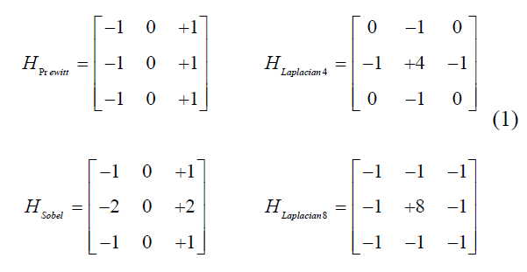

By comparing coefficients in matrices HPrewitt and HSobel can be quickly seen that the Sobel edge detector is very similar to the Prewitt with only difference in emphasizing centre pixels (i.e. nearest pixels in 4-neighbourhood of the central one). This results in insignificant differences between output edge-images of these two operators in practice. Fig. 3 shows an original image of a scene with an ARTag (marker with unique code used e.g. for indoor robots navigation) and the resulting edge-image using the Sobel operator.

The input RGB image from RPiCam with resolution of 320x240 pixels and the relevant result of the Sobel operator. Edge images, similar to the depicted one, are either important inputs to scene understanding blocks or even necessary inputs to several image transforms as for example the Hough transform described below.

**B. Corner Detection by Harris Operator**

A corner detection is the next qualitative level in an image understanding. All known corner detectors generally differ from edge detectors in stronger response in places where corner is present in comparison with places where only edge appears.

The most simple corner detector is the Moravec operator only summing eight differences between a central pixel and pixels in the 8-neighbourhood. More sophisticated corner detectors named after their authors are Harris and Stephens algorithm, Shi and Tomasi algorithm and finally Rosten and Drummond algorithm. The use of the Harris and Stephens corner detector is done for Simulink tests. It is based on an autocorrelation function of a small patch of the input image. A first step in the Harris algorithm is to compute a Harris matrix, the matrix containing all combinations of gradients in horizontal and vertical direction. When the horizontal and vertical gradients are denoted as Ix and Iy, respectively, the Harris matrix A will be given by the equation (2).

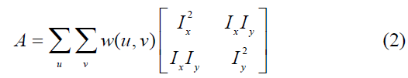

Corners are places in an image where gradients are significant in both the horizontal and the vertical direction simultaneously. It follows eigenvalues lambda 1 and lambda 2 of the Harris matrix can distinguish flat patches, edges and corners from each other. In order to do this, easy to compute function H indicating corner by its high value were suggested by Harris and Stephnes. The H function is given by an equation (3), where the dot (A) stands for a matrix determinant and the trace (A) stands for a sum of values along its main diagonal. Maximums in this metric map depicted into the original image by purple crosses. A metric map as a grayscale image computed by the Harris and Stephens algorithm (on the left) and strongest detected corners imprinted into the input image (on the right).



Corners play, similarly as edges, very important role in image understanding step as input points for computation region descriptors e.g. SURF, MSER, BRISK, etc. Usage of such stable and reliable descriptors facilitates object tracking and recognition in an unknown scene.

**C. Line Detection by Hough Transform**

The Hough transform is conversion of coordinates of all non-zero pixels in an input binary image to an abstract space of parameters. These parameters are exactly given by an analytical equation of a sought-after shape (e.g. line, circle, ellipse, etc.). In that resultant parameters space a desired number of peaks (i.e. global maximums) are detected and finally respective space coordinates are then transformed back into the image plane in form of detected entity (line, circle, etc.) The most common is the Hough transform for line and circles detection. The first one plays a significant role in mobile robotics navigation and scene understanding.

An arbitrary line of perpendicular distance (rho) from the origin and angle (theta) of inclination of a normal line from the x-axis can be represented in parametric form given by the equation (4).



In this case, a two-dimensional space of image coordinates (X, Y) is mapped into a new space of line-equation parameters are often also called a Hough accumulator. As the x and y coordinates of each nonzero pixel in the input binary image (three black highlighted dots) are transformed to the one couple of parameters. A relevant point of the computed coordinates is increased by 1 in the accumulator. Such voting system causes that all pixels lying in one straight line create a peak in the accumulator with maximal value equal to a number of pixels in the line. Non-ideal (i.e. not exactly straight) shape of line results in a blurred peak, but still distinguished from generally lower values in a neighbourhood of this peak. Coordinates rho and theta of each local maximum can be simply displayed in the input image as lines. User itself via an algorithm selects a number of strongest peaks to be displayed. [2]

**2.2 History:**

Traditional ways for personal identification depend on external things such as keys, passwords, etc. But such things may be lost or forgotten. One possible way to solve these problems is through biometrics, for every person has his special biometric features definitely. Biometrics identification has gained increasing attention from the whole world. Biometrics features that can be used for identification include fingerprints, palm prints, Handwriting, vein pattern, facial characteristics, face, and some other methods such as voice pattern, etc. Compared with other biometric methods, the face recognition has the following advantages: The face image acquisition requires no physical contact, so face Identification system is non-invasiveness. Since the face is created in a nearly random morphogenetic process during the gestation, it has little probability to find two people in the world whose face textures are identical. So face recognition is the most accurate method and has the lowest false recognition rate. The face recognition has more stability than other biometric identification methods because the face has much more features than other biometrics and it won’t change in people’s life. With the advantages of non-invasiveness, Uniqueness, stability and low false recognition rate, face recognition has been researched widely and has a broad usage, such as security, attendance, etc. Most of the recognition systems are based on PC. [3]

However, the portability of PC is limited by its weight, size and the high power consumption. Thus results in that the using of face recognition is confined in few fields, and it is inconvenient to use. The way to get rid of the limit of PC is using embedded system. The designed platform acquires the images and stores them into the real time database , which in turn later used for comparing the faces of the users to provide access to them or to deny the access to a place or to operate a device. Recent technological advances are enabling a new generation of smart cameras that represent a quantum leap in sophistication. While today's digital cameras capture images, smart cameras capture high-level descriptions of the scene and analyse what they see. These devices could support a wide variety of applications including human and animal detection, surveillance, motion analysis, and facial identification. Fortunately, Moore's law provides an increasing pool of available computing power to apply to real-time analysis. Smart cameras leverage very large-scale integration (VLSI) to provide such analysis in a low-cost, low-power system with substantial memory. Moving well beyond pixel Processing and compression, these systems run a wide range of algorithms to extract meaning from streaming video. Because they push the design space in so many dimensions, image capturing are a leading edge application for embedded system research. Most of the capturing systems are based on PC. [3]

**2.3 Recent development:**

All steel industries aim to produce various competitive steel products. The competition enhancement depends mainly on productivity and quality of the steel produced by each industry. In this sector, there have been an enlarge amount of losses due to defective products. Most defects arising in the production process are still detected by human inspection. The work of inspectors is very tedious and time consuming. The identification rate is about 70%. In addition, the effectiveness of visual inspection decreases quickly with fatigue. Digital image processing techniques have been increasingly applied to steel bearing samples for analysing the product. As the technological progress is happening the products are now extensively made using steel material which needs to be ultra-light weight and modular in nature steel components like bearing, as per industry statistics, researchers have found that bearing are made up of steel material which is prone to various kinds of defects when manufacturing using image processing. Therefore a fully robust system taking advantage of image processing techniques (Image segmentation, Non smooth corner detection etc.) must be explored to build an economical solution to provide Total Quality Management in manufacturing units which would allow an eco-system of continuous monitoring and improvement there by reducing the cost. [7]

Measuring 3D shape of an object is an important technique for the structural and kinematic analysis, the object digital archiving, referencing over the network, and so on. Hence, many 3D shape measuring instruments have been developed such as arm-typed digitizers, laser range finders, and stereo cameras and so on. But, these instruments are usually large scale and expensive, so everyone cannot use these instruments. Hence a method proposed here is the object shape measuring method using the image scanner which has three colour light sources, red, green and blue. And also have proposed the method using the stereo image scanner which has two colour charged coupled device sensors. But, there are some problems in these method. Assuming that the colour of the object surface should be known, it is difficult to estimate the adequate approximate shape previously, and using two colour charged coupled device sensors has a problem in respect of cost. To overcome these problems, a new shape measuring method using the image scanner which has three white light sources and one colour charged coupled device sensor. The 3D shape measuring method using multiple light sources is called “the photometric stereo”. This method usually assume the parallel light sources to simplify the photometric models. In this case, the surface normal vectors on the over all of the object surface are estimated as the shape data. On the other hand, the light sources used in the image scanner are the long fluorescent lights, and these light sources are close to the object surface. Hence, the illuminate intensity changes with the distance from the light source. Under such condition, an estimation of the surface normal vectors and the distance from the light sources as the object shape information is must. Moreover, the reflectance intensity also changes with the colour of the object surface. Therefore, the surface normal vectors, the distance from the light source and the object surface colour have the interdependence relations in the photometric models, and estimation of these parameters to measure the object shape. The method here estimates approximate albedos (colour) before the shape measuring. The method describes as follows, in a colour scanned image under white light sources, the colour on an object changes its brightness and saturation according to its shape. But its hue does not almost change, hence approximation of albedos from the colour scanned image is directly obtained. The object shape is estimated by using approximate albedos. The other method estimates the shape parameters first using the photometric models which is constructed to eliminate the colour parameters from the multiple photometric models. Next, estimation of the colour parameters using obtained shape parameters is implemented. And these estimations are iterated until the shape and colour parameters are converged accurately. [7]

**CHAPTER III**

**DESIGN AND DEVELOPMENT**

**Chapter-3**

**Design and Development**

This chapter includes the overall design and development of the project. It also explains the procedure of hardware and software modules of the system. This chapter encapsulated the block diagram, flow chart & algorithm of the system.

**3.1 Block Diagram & Description:**

This is the basic Block Diagram for the proposed project as shown in the Fig. consists of following components, Raspberry Pi 2 which is used for image processing and measuring the dimensions of the Job. Also it used to detect error in the Job measured. Web Camera Device, 16X2 LCD Display to display the length and breadth of the Job and Red and Green LED’s are interfaced with the Raspberry Pi system. An external Power Supply is also used.

PC

Ethernet Cable

Raspberry Pi Controller

Power Supply

16X2 LCD Display

Camera

LED’S

**Fig. (3.1) Block Diagram of the system**

**Description:**

In the proposed system, Raspberry Pi controller is interfaced with Web Camera for clicking the image of respective objects, LCD Display and LED’s. Further, Raspberry pi controller is connected with PC by using an Ethernet Cable. First, LCD and Web Camera device is initialised. Then, the power supply is provided to the Raspberry Pi Controller.

The object is then placed in front of the camera and video capturing is then initiated. When the object stabilizes, the dimensions (i.e. Length and Breadth) are measured using edges and mid-points of the object and displayed on the LCD.

Now, as per the requirements, the master dimensions are already provided to the controller. Now, the measured dimensions of the object is compared with the master dimensions. If there is a change in the pixel count of the image captured, Red LED glows which indicates the error. If the pixel count matches with the captured image then, Green LED glows which indicates no error.

**3.2 Algorithm:**

1. Start

2. Initialise the Web Camera

3. Begin video capturing

4. Initialise the LCD

5. Capture the image of the Job

6. Save the image captured in the SD Card of the Raspberry Pi

7. Display the dimensions of the Job on the LCD.

8. Compare the image to the pixel count (Master Dimensions)

9. Check if the pixel count of the image captured and master dimensions matches

10. If there is a change in the dimensions, error is detected via LED

11. End

**3.3 Flowchart:**

START

INITIALISE THE WEB CAMERA

INITIALISE THE LCD

BEGIN VIDEO CAPTURING

CAPTURE THE IMAGE OF THE JOB

DISPLAY THE DIMENSIONS OF THE JOB ON THE LCD DISPLAY

COMPARE THE PIXELS OF THE IMAGE TO THAT OF THE MASTER DIMENSION PIXELS

IF THE PIXEL COUNT IS SAME

YES NO

RED LED TURNS ON

GREEN LED TURNS ON

END

**3.4 Hardware Specification:**

**3.4.1 Raspberry Pi 2 Model B:**

The Raspberry Pi is a series of small single-board computers developed in the United Kingdom by the Raspberry Pi Foundation to promote the teaching of basic computer science in schools and in developing countries. The original model became far more popular than anticipated, selling outside of its target market for uses such as robotics. Peripherals (including keyboards, mice and cases) are not included with the Raspberry Pi. Some accessories however have been included in several official and unofficial bundles.

According to the Raspberry Pi Foundation, over 5 million Raspberry Pi is have been sold before February 2015, making it the best-selling British computer.By November 2016 they had sold 11 million units.

Several generations of Raspberry Pi have been released. The first generation (Raspberry Pi 1 Model B) was released in February 2012. It was followed by a simpler and inexpensive model Model A. In 2014, the foundation released a board with an improved design in Raspberry Pi 1 Model B+. These boards are approximately credit-card sized and represent the standard mainline form-factor. Improved A+ and B+ models were released a year later. A "compute module" was released in April 2014 for embedded applications, and a Raspberry Pi Zero with smaller size and reduced input/output (I/O) and general-purpose input/output (GPIO) capabilities was released in November 2015 for US$5. The Raspberry Pi 2 which added more RAM was released in February 2015. Raspberry Pi 3 Model B released in February 2016, is bundled with on-board WiFi, Bluetooth and USB boot capabilities.[11] As of January 2017, Raspberry Pi 3 Model B is the newest mainline Raspberry Pi. Raspberry Pi boards are priced between US$5–35. As of 28 February 2017, the Raspberry Pi Zero W was launched, which is identical to the Raspberry Pi Zero, but has the Wi-Fi and Bluetooth functionality of the Raspberry Pi 3 for US$10.

All models feature a Broadcom system on a chip (System on chip), which includes an ARM compatible central processing unit (Central Processing Unit) and an on-chip graphics processing unit (Graphics processing unit, a VideoCore IV). CPU speed ranges from 700 MHz to 1.2 GHz for the Pi 3 and on board memory range from 256 MB to 1 GB RAM. Secure Digital (SD) cards are used to store the operating system and program memory in either the Secure Digital High capacity or MicroSD sizes. Most boards have between one and four USB slots, HDMI and composite video output, and a 3.5 mm phone jack for audio. Lower level output is provided by a number of GPIO pins which support common protocols like I²C. The B-models have an 8P8C Ethernet port and the Pi 3 and Pi Zero W have on board Wi-Fi 802.11n and Bluetooth.

The Foundation provides Raspbian, a Debian-based Linux distribution for download, as well as third party Ubuntu, Windows 10 IOT Core, RISC OS, and specialised media centre distributions. It promotes Python and Scratch as the main programming language, with support for many other languages. The default firmware is closed source, while an unofficial open source is available. [4]

**Hardware:**

The Raspberry Pi hardware has evolved through several versions that feature variations in memory capacity and peripheral-device support.

This Fig. (3.4.1.a) depicts Models A, B, A+, and B+. Model A, A+, and the Pi Zero lack the Ethernet and USB hub components. The Ethernet adapter is internally connected to an additional USB port. In Model A, A+, and the Pi Zero, the USB port is connected directly to the system on a chip. On the Pi 1 Model B+ and later models the USB/Ethernet chip contains a five-point USB hub, of which four ports are available, while the Pi 1 Model B only provides two. On the Pi Zero, the USB port is also connected directly to the chip, but it uses a micro USB port.

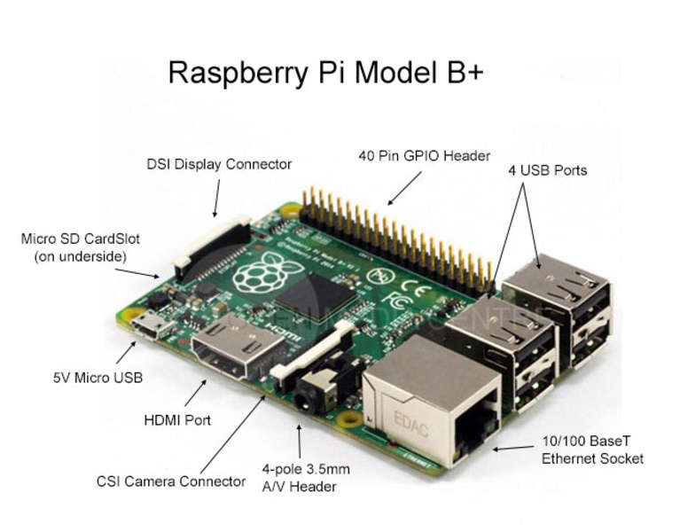

**Fig. (3.4.1.a) Raspberry Pi Model B+**

**Processor:**

The Raspberry Pi 2 uses a 32-bit 900 MHz quad-core ARM Cortex-A7 processor. The Broadcom BCM2835 SoC used in the first generation Raspberry Pi is somewhat equivalent to the chip used in first generation smartphones (its CPU is an older ARMv6 architecture), which includes a 700 MHz ARM1176JZF-S processor, VideoCore IV graphics processing unit (GPU), and RAM. It has a level 1 (L1) cache of 16 KB and a level 2 (L2) cache of 128 KB. The level 2 cache is used primarily by the GPU. The SoC is stacked underneath the RAM chip, so only its edge is visible.

The Raspberry Pi 2 uses a Broadcom BCM2836 SoC with a 900 MHz 32-bit quad-core ARM Cortex-A7 processor (as do many current smartphones), with 256 KB shared L2 cache.

The Raspberry Pi 3 uses a Broadcom BCM2837 SoC with a 1.2 GHz 64-bit quad-core ARM Cortex-A53 processor, with 512 KB shared L2 cache. [8]

**Performance:**

The Raspberry Pi 3, with a quad-core Cortex-A53 processor, is described as 10 times the performance of a Raspberry Pi 1 was suggested to be highly dependent upon task threading and instruction set use. Benchmarks showed the Raspberry Pi 3 to be approximately 80% faster than the Raspberry Pi 2 in parallelized tasks.

Raspberry Pi 2 includes a quad-core Cortex-A7 CPU running at 900 MHz and 1 GB RAM. It is described as 4–6 times more powerful than its predecessor. The GPU is identical to the original. In parallelized benchmarks, the Raspberry Pi 2 could be up to 14 times faster than a Raspberry Pi 1 Model B+.

While operating at 700 MHz by default, the first generation Raspberry Pi provided a real-world performance roughly equivalent to 0.041 GFLOPS. On the CPU level the performance is similar to a 300 MHz Pentium II of 1997–99. The GPU provides 1 G Pixel/s or 1.5 G Texel/s of graphics processing or 24 GFLOPS of general purpose computing performance. The graphical capabilities of the Raspberry Pi are roughly equivalent to the performance of the Xbox of 2001.

The LINPACK single node compute benchmark results in a mean single precision performance of 0.065 GFLOPS and a mean double precision performance of 0.041 GFLOPS for one Raspberry Pi Model-B board. A cluster of 64 Raspberry Pi Model B computers, labeled "Iridis-pi", achieved a LINPACK HPL suite result of 1.14 GFLOPS (n=10240) at 216 watts for c. US$4000.

**Overclocking**:

The CPU chips of the first and second generation Raspberry Pi board did not require cooling, such as a heat sink, unless the chip was overclocked, but the Raspberry Pi 2 SoC may heat more than usual under overclocking. [Citation needed]

Most Raspberry Pi chips could be overclocked to 800 MHz, and some to 1000 MHz. There are reports the Raspberry Pi 2 can be similarly overclocked, in extreme cases, even to 1500 MHz (discarding all safety features and over-voltage limitations). In the Raspbian Linux distro the overclocking options on boot can be done by a software command running "sudo raspi-config" without voiding the warranty. In those cases the Pi automatically shuts the overclocking down if the chip reaches 85 °C (185 °F), but it is possible to override automatic over-voltage and overclocking settings (voiding the warranty); an appropriately sized heat sink is needed to protect the chip from serious overheating.

Newer versions of the firmware contain the option to choose between five overclock ("turbo") presets that when used, attempt to maximize the performance of the SoC without impairing the lifetime of the board. This is done by monitoring the core temperature of the chip, the CPU load, and dynamically adjusting clock speeds and the core voltage. When the demand is low on the CPU or it is running too hot the performance is throttled, but if the CPU has much to do and the chip's temperature is acceptable, performance is temporarily increased with clock speeds of up to 1 GHz depending on the individual board and on which of the turbo settings is used.

The seven overclock presets are:

none; 700 MHz ARM, 250 MHz core, 400 MHz SDRAM, 0 overvolt,

modest; 800 MHz ARM, 250 MHz core, 400 MHz SDRAM, 0 overvolt,

medium; 900 MHz ARM, 250 MHz core, 450 MHz SDRAM, 2 overvolt,

high; 950 MHz ARM, 250 MHz core, 450 MHz SDRAM, 6 overvolt,

turbo; 1000 MHz ARM, 500 MHz core, 600 MHz SDRAM, 6 overvolt,

Pi 2; 1000 MHz ARM, 500 MHz core, 500 MHz SDRAM, 2 overvolt,

Pi 3; 1100 MHz ARM, 550 MHz core, 500 MHz SDRAM, 6 overvolt. In system information CPU speed will appear as 1200 MHz When in idle speed lowers to 600 MHz

In the highest (turbo) preset the SDRAM clock was originally 500 MHz, but this was later changed to 600 MHz because 500 MHz sometimes causes SD card corruption. Simultaneously in high mode the core clock speed was lowered from 450 to 250 MHz, and in medium mode from 333 to 250 MHz

The Raspberry Pi Zero runs at 1 GHz.

**RAM:**

On the older beta Model B boards, 128 MB was allocated by default to the GPU, leaving 128 MB for the CPU. On the first 256 MB release Model B (and Model A), three different splits were possible. The default split was 192 MB (RAM for CPU), which should be sufficient for standalone 1080p video decoding, or for simple 3D, but probably not for both together. 224 MB was for Linux only, with only a 1080p frame buffer, and was likely to fail for any video or 3D. 128 MB was for heavy 3D, possibly also with video decoding (e.g. XBMC). Comparatively the Nokia 701 uses 128 MB for the Broadcom VideoCore IV. For the new Model B with 512 MB RAM initially there were new standard memory split files released( arm256_start.elf, arm384_start.elf, arm496_start.elf) for 256 MB, 384 MB and 496 MB CPU RAM (and 256 MB, 128 MB and 16 MB video RAM). But a week or so later the RPF released a new version of start. Elf that could read a new entry in config.txt (gpu_mem=xx) and could dynamically assign an amount of RAM (from 16 to 256 MB in 8 MB steps) to the GPU, so the older method of memory splits became obsolete, and a single start. Elf worked the same for 256 and 512 MB Raspberry Pi.

The Raspberry Pi 2 and the Raspberry Pi 3 have 1 GB of RAM. The Raspberry Pi Zero and Zero W have 512 MB of RAM.

**Networking:**

The Model A, A+ and Pi Zero have no Ethernet circuitry and are commonly connected to a network using an external user-supplied USB Ethernet or Wi-Fi adapter. On the Model B and B+ the Ethernet port is provided by a built-in USB Ethernet adapter using the SMSC LAN9514 chip. The Raspberry Pi 3 and Pi Zero W (wireless) are equipped with 2.4 GHz Wi-Fi 802.11n (150 Mbit/s) and Bluetooth 4.1 (24 Mbit/s) based on Broadcom BCM43438 FullMAC chip with no official support for Monitor mode but implemented through unofficial firmware patching and the Pi 3 also has a 10/100 Ethernet port.

**Peripherals:**

The current Model B boards incorporate four USB ports for connecting peripherals.

The Raspberry Pi may be operated with any generic USB computer keyboard and mouse. It may also be used with USB storage, USB to MIDI converters, and virtually any other device/component with USB capabilities.

Other peripherals can be attached through the various pins and connectors on the surface of the Raspberry Pi.

**Video:**

The early Raspberry Pi 1 Model A, with an HDMI port and a standard RCA composite video port for older displays

The video controller can emit standard modern TV resolutions, such as HD and Full HD, and higher or lower monitor resolutions and older standard CRT TV resolutions. As shipped (i.e., without custom overclocking) it can emit these: 640×350 EGA; 640×480 VGA; 800×600 SVGA; 1024×768 XGA; 1280×720 720p HDTV; 1280×768 WXGA variant; 1280×800 WXGA variant; 1280×1024 SXGA; 1366×768 WXGA variant; 1400×1050 SXGA+; 1600×1200 UXGA; 1680×1050 WXGA+; 1920×1080 1080p HDTV; 1920×1200 WUXGA.

Higher resolutions, such as, up to 2048×1152, may work or even 3840×2160 at 15 Hz (too low a frame rate for convincing video). Note also that allowing the highest resolutions does not imply that the GPU can decode video formats at those; in fact, the Pis are known to not work reliably for H.265 (at those high resolutions), commonly used for very high resolutions (most formats, commonly used, up to Full HD, do work).

Although the Raspberry Pi 3 does not have H.265 decoding hardware, the CPU is more powerful than its predecessors, potentially fast enough to allow the decoding of H.265-encoded videos in software. The GPU in the Raspberry Pi 3 runs at a higher clock frequencies of 300 MHz or 400 MHz, compared to previous versions which ran at 250 MHz

The Raspberry Pis can also generate 576i and 480i composite video signals, as used on old-style (CRT) TV screens and less-expensive monitors through standard connectors – either RCA or 3.5 mm phone connector depending on models. The television signal standards supported are PAL-BGHID, PAL-M, PAL-N, NTSC and NTSC-J.

**Real-time clock:**

None of the current Raspberry Pi models have a built-in real-time clock, so they are unable to keep track of the time of day independently. As a workaround, a program running on the Pi can retrieve the time from a network time server or from user input at boot time, thus knowing the time while powered on. To provide consistency of time for the file system, the Pi does automatically save the time it has on shutdown, and re-installs that time at boot.

A real-time hardware clock with battery backup, such as the DS1307, which is fully binary coded, may be added (often via the I²C interface).

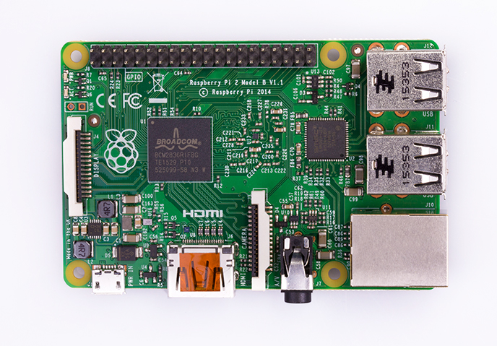

**Fig. (3.4.1.b) Raspberry Pi Model B+ Internal Configuration**

**Technical Specifications:**

* Broadcom BCM2837 Arm7 Quad Core Processor powered Single Board Computer running at 900MHz
* 1GB RAM
* 40pin extended GPIO
* 4 x USB 2 ports
* 4 pole Stereo output and Composite video port
* Full size HDMI
* CSI camera port for connecting the Raspberry Pi camera
* DSI display port for connecting the Raspberry Pi touch screen display
* Micro SD port for loading the user operating system and storing data
* Micro USB power source

**Raspberry Pi 2 Model B Features:**

* Broadcom BCM2837Arm7 Quad Core Processor powered Single Board Computer running at 900MHz
* 1GB RAM so the user can now run bigger and more powerful applications
* Identical board lathe user and footprint as the Model B+, so all cases and 3rd party add-on boards designed for the Model B+ will be fully compatible.
* Fully HAT compatible
* 40pin extended GPIO to enhance the user “real world” projects. GPIO is 100% compatible with the Model B+ and A+ boards. First 26 pins are identical to the Model A and Model B boards to provide full backward compatibility across all boards.
* Connect a Raspberry Pi camera and touch screen display (each sold separately)
* Stream and watch Hi-definition video output at 1080P
* Micro SD slot for storing information and loading the user operating systems.
* Advanced power management:
* The user can now provide up to 1.2 AMP to the USB port – enabling the user to connect more power hungry USB devices directly to the Raspberry PI. (This feature requires a 2Amp micro USB Power Supply)
* 10/100 Ethernet Port to quickly connect the Raspberry Pi to the Internet
* Combined 4-pole jack for connecting the user stereo audio out and composite video out [8]

**3.4.2 Live Tech Web Camera Device:**

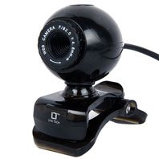

**Fig. (3.4.2) Live tech Web Camera**

The LT 8 Mega Pixel Web Cam has a dynamic range of 72dB and a focus range of 3cm-infinity.It has**a** built-in image compression mechanism**.** The camera also has**a**utomatic white balanceand dynamic image E-mail. It also hasmanual focus and a shutterk**ey.**Other important features are- CMOS chip Type: Colour CMOS image sensor, high resolving power: 640x480**,** Video Format: 24bit RGB, Interface**:** USB**,** Frame Rate: 640x480 up to 30 frame/sec,640x480 up to 15 frame/se(VGA**),**Sensor size: 4386x3.64mm and S/N ratio: 48dB.

**Highlights:**

* CMOS chip Type: Colour CMOS image sensor
* High Resolving power: 640x480
* Video Format: 24bit RGB
* Interface: USB
* Dynamic range: 72dB
* Focus range: 3cm-infinity
* Built-in image compression
* Automatic white balance
* Dynamic image E-mail
* Manual focus
* Shutter Key
* SUPC: 1818745

|  |  |  |  |  |  |  |
| --- | --- | --- | --- | --- | --- | --- |
| |  |  | | --- | --- | | **Brand** | | | Brand Name | Live Tech | | Model | LT 8 Mega Pixel Web Cam | |
| |  |  | | --- | --- | | **Specifications** | | | CMOS chip Type | Colour CMOS image sensor | | HI. Resolving power | 640x480 | |
| |  |  | | --- | --- | | **Format** | | | Video Format | 24bit RGB | |
| |  |  | | --- | --- | | **Interface / Frame Rate** | | | Interface | USB | | Frame Rate | 640x480 up to 30 frame/sec, 640x480 up to 15 frame/se(VGA) | |
| |  |  | | --- | --- | | **Range** | | | Dynamic range | 72dB | | Focus range | 3cm-infinity | |
| |  |  | | --- | --- | | **General** | | | Built-in image compression | Yes | | Automatic white balance | Yes | | manual focus | Yes | | Shutter Key | Yes | | Sensor size | 4386x3.64mm | | S/N ratio | 48dB | |

|  |
| --- |
|  |

**3.4.3 16X2 LCD Display:**

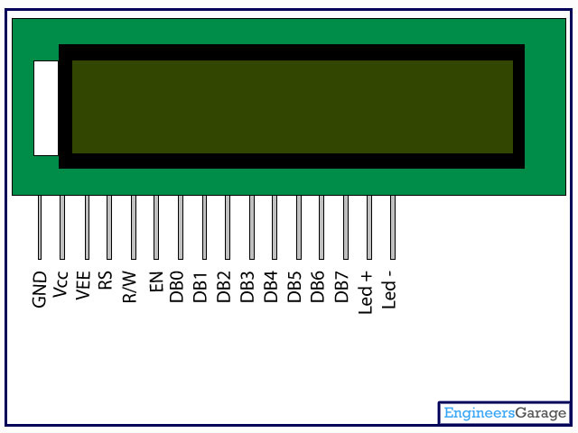

**Fig. (3.4.3) LCD Display**

LCD (Liquid Crystal Display) screen is an electronic display module and find a wide range of applications. A 16x2 LCD display is very basic module and is very commonly used in various devices and circuits. These modules are preferred over seven segments and other multi segment [LED](http://www.engineersgarage.com/content/led)s. The reasons being: LCDs are economical; easily programmable; have no limitation of displaying special & even [custom characters](http://www.engineersgarage.com/microcontroller/8051projects/create-custom-characters-LCD-AT89C51) (unlike in seven segments), [animations](http://www.engineersgarage.com/microcontroller/8051projects/display-custom-animations-LCD-AT89C51) and so on.

A **16x2 LCD** means it can display 16 characters per line and there are 2 such lines. In this LCD each character is displayed in 5x7 pixel matrix. This LCD has two registers, namely, Command and Data.

The command register stores the command instructions given to the LCD. A command is an instruction given to LCD to do a predefined task like initializing it, clearing its screen, setting the cursor position, controlling display etc. The data register stores the data to be displayed on the LCD. The data is the ASCII value of the character to be displayed on the LCD.

**Pin Description:**

|  |  |  |
| --- | --- | --- |
| **Pin No** | **Function** | **Name** |
| 1 | Ground (0V) | Ground |
| 2 | Supply voltage; 5V (4.7V – 5.3V) | Vcc |
| 3 | Contrast adjustment; through a variable resistor | VEE |
| 4 | Selects command register when low; and data register when high | Register Select |
| 5 | Low to write to the register; High to read from the register | Read/write |
| 6 | Sends data to data pins when a high to low pulse is given | Enable |
| 7 | 8-bit data pins | DB0 |
| 8 | DB1 |
| 9 | DB2 |
| 10 | DB3 |
| 11 | DB4 |
| 12 | DB5 |
| 13 | DB6 |
| 14 | DB7 |
| 15 | Backlight VCC (5V) | Led+ |
| 16 | Backlight Ground (0V) | Led- |

**Table (3.4.3) Pin Description of LCD**

**3.4.4 LED:**

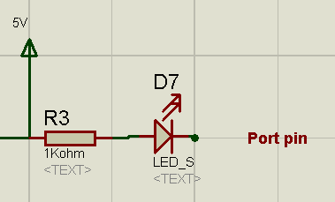

**Fig. (3.4.4.a) LED**

**Description:**

This is a very basic 5mm LED with a red and green lens. It has a typical forward voltage of 2.0V and a rated forward current of 20mA.

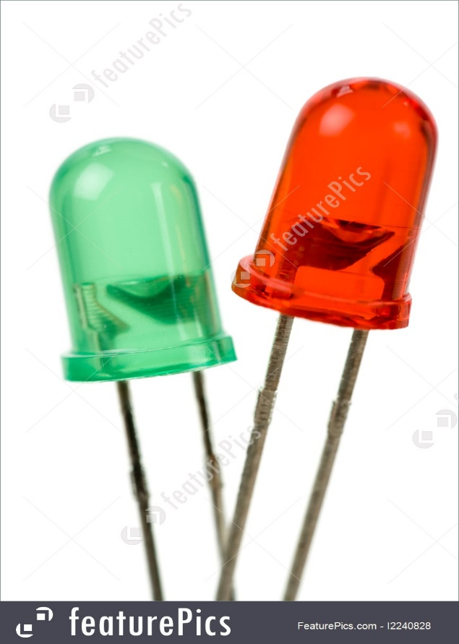

**Fig. (3.4.4.b) Red and Green LED’s**

**Features:**

* 1.8-2.2VDC forward drop
* Max current: 20mA
* Suggested using current: 16-18mA
* Luminous Intensity: 150-200mcd

**Specifications:**

* Voltage 5V
* D7 LED and R3 current limiting Resistance
* Current = Voltage /Resistance
* Current =5v /1000 =5 mamp
* More the resistance less the current so less is the intensity
* When Port pin is 5V 🡪 LED off
* When Port pin is 0V 🡪 LED ON
* Active low

**3.4.5 Ethernet Cable:**

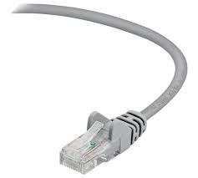

**Fig. (3.4.5) Ethernet Cable**

An [Ethernet](https://www.lifewire.com/definition-of-ethernet-816312) cable is one of the most popular forms of network cable used on wired networks. Ethernet cables connect devices together within a [local area network](https://www.lifewire.com/local-area-network-816382), like PCs, [routers](https://www.lifewire.com/how-routers-work-816456), and [switches](https://www.lifewire.com/definition-of-network-switch-817588).

Given that these are physical cables, they do have their limitations, both in the distance that they can stretch and still carry proper signals, and their durability. This is one reason there are different types of Ethernet cables; to perform certain tasks in particular situations.

### Types of Ethernet Cables

Ethernet cables normally support one or more industry standards including [Category 5 (CAT5)](https://www.lifewire.com/cat5-ethernet-cable-standard-817552) and [Category 6 (CAT6)](https://www.lifewire.com/cat6-ethernet-cable-standard-817553).

A [crossover cable](https://www.lifewire.com/crossover-cable-ethernet-817870) is a special type of Ethernet cable specially designed for connecting two computers to each other. By contrast, most Ethernet cables are designed to connect one computer to a router or switch.

Ethernet cables are physically manufactured in two basic forms called solidandstranded*.*

Solid Ethernet cables offer slightly better performance and improved protection against electrical interference. They're also more commonly used on [business networks](https://www.lifewire.com/business-computer-networks-817883), wiring inside office walls, or under lab floors to fixed locations

Stranded Ethernet cables are less prone to physical cracks and breaks, making them more suitable for travellers or in home networking setups.

### Limitations of Ethernet Cables

A single Ethernet cable, like an electric power cord, has a limited maximum distance capacity, meaning they have an upper limit to how long they can be before signal loss (called [attenuation](https://www.lifewire.com/attenuation-and-amplification-817892)) happens. This is due to their electrical transmission characteristics and is directly affected by interference around the cable.

Both ends of the cable should be close enough to each other to receive signals quickly, but far enough away from electrical interferences to avoid interruptions. However, this alone doesn't limit the size of a network because hardware like routers or hubs can be used to join multiple Ethernet cables together within the same network. This distance between two devices is called the network diameter.

The maximum length of a single CAT5 cable, before attenuation occurs, is 324 feet. CAT6 can go up to around 700 feet. Keep in mind that Ethernet cables can be longer but they might suffer from signal loss, especially if there are other electrical appliances that the cable passes by.

**3.4.6 Power Supply:**

High quality ERD 5V 2A USB adapter with cable compatible for Raspberry Pi 3 Model B / RPi 2 Model B / RPi B+ / A+ with Three months manufacturer warranty (against manufacturing defects).

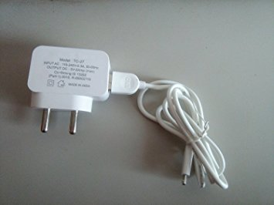

**Fig. (3.4.6) Power Supply**

**Features & Technical Details:**

* Input Voltage: 110V-240V AC 0.3A 50-60Hz
* Available Outputs: 5V-2Amp (Max)
* Stabilized Output, low ripple & low interference
* Short Circuit and Overload Protection
* High Efficiency and Low energy Consumption

**3.5 Software Specification:**

**3.5.1 MATLAB PC:**

### Read, Write, and Analyse Data from Raspberry Pi Sensors and Cameras

[MATLAB support package for Raspberry Pi](https://in.mathworks.com/hardware-support/raspberry-pi-matlab.html?s_tid=srchtitle) lets the user write MATLAB programs that communicate with Raspberry Pi and acquire data from the board’s GPIO pins, cameras, and other connected devices. Because MATLAB is a high-level interpreted language, it is easy to prototype and refine algorithms for the user for Raspberry Pi projects. MATLAB includes thousands of built-in math and plotting functions that the user can use for Raspberry Pi programming, covering domains such as image and video processing, optimization, statistics, and signal processing.

[[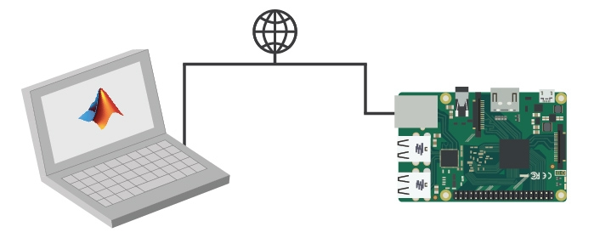](https://in.mathworks.com/content/mathworks/in/en/discovery/raspberry-pi-programming-matlab-simulink/_jcr_content/mainParsys/image_0.img.jpg/1494882038467.jpg)](https://in.mathworks.com/content/mathworks/in/en/discovery/raspberry-pi-programming-matlab-simulink/_jcr_content/mainParsys/image_0.img.jpg/1494882038467.jpg)

**Fig. (3.5.1.a) MATLAB PC**

With MATLAB support package for Raspberry Pi, the Raspberry Pi is connected to a computer running MATLAB. Processing is done on the computer with MATLAB.

Using MATLAB for Raspberry Pi programming lets the user:

* [Analyse](https://in.mathworks.com/solutions/data-analysis.html) Raspberry Pi sensor data using thousands of prebuilt functions for [image processing](https://in.mathworks.com/solutions/image-video-processing.html), [signal processing](https://in.mathworks.com/solutions/dsp.html), [mathematical modelling](https://in.mathworks.com/solutions/mathematical-modeling.html), and more.
* Quickly visualize the user data using the vast array of MATLAB [plot types](https://in.mathworks.com/products/matlab/plot-gallery.html).
* Use the same software to program other hardware devices, such as [Arduino](https://in.mathworks.com/discovery/arduino-programming-matlab-simulink.html)[®](https://in.mathworks.com/discovery/arduino-programming-matlab-simulink.html) and BeagleBone Black.

[Connecting MATLAB to Raspberry Pi to prototype an image processing algorithm 7.10](https://www.youtube.com/watch?v=oqjitgPM2f0&index=10&list=PLn8PRpmsu08rl1WhIlK-gj2H-6koUAHoh)

### Develop Algorithms That Run Standalone on the Raspberry Pi.

[Simulink Support Package for Raspberry Pi](https://in.mathworks.com/hardware-support/raspberry-pi-simulink.html) lets the user develop algorithms in Simulink, a block diagram environment for modelling dynamic systems and developing algorithms, and run them standalone on the Raspberry Pi. The support package extends Simulink with blocks for configuring the Raspberry Pi, sending and receiving UDP packets, and reading and writing data from sensors. This includes writing data to the free [Thing Speak](https://in.mathworks.com/hardware-support/thingspeak.html) data aggregation service for Internet of Things applications.

After creating the Simulink model, the user can simulate it, tune algorithm parameters until the user get it just right, and download the completed algorithm for standalone execution on the device. With the [MATLAB Function block](https://in.mathworks.com/help/simulink/ug/what-is-a-matlab-function-block.html?s_cid=srchtitle), the user can incorporate MATLAB code into the Simulink model.

[[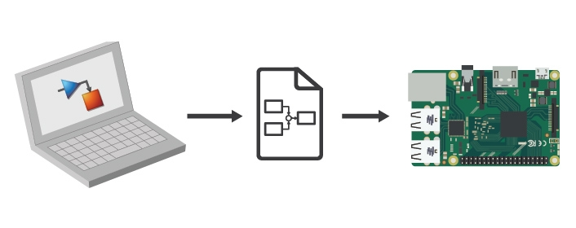](https://in.mathworks.com/content/mathworks/in/en/discovery/raspberry-pi-programming-matlab-simulink/_jcr_content/mainParsys/image_1.img.jpg/1494882038512.jpg)](https://in.mathworks.com/content/mathworks/in/en/discovery/raspberry-pi-programming-matlab-simulink/_jcr_content/mainParsys/image_1.img.jpg/1494882038512.jpg)

**Fig. (3.5.1.b) MATLAB PC**

With Simulink support package for Raspberry Pi, the user develop the algorithm in Simulink and deploy to the Raspberry Pi using automatic code generation. Processing is then done on the Raspberry Pi.

Using Simulink for Raspberry Pi programming lets the user:

* [Develop and simulate the user algorithms in Simulink](https://in.mathworks.com/products/simulink/features.html) and use automatic code generation to run them on the device.
* Incorporate signal processing, [control design](https://in.mathworks.com/discovery/control-design-software.html), [state logic](https://in.mathworks.com/products/stateflow.html), and other advanced math and engineering routines in the user Raspberry Pi programming projects.
* Interactively tune and optimize parameters as the user algorithm runs on the Raspberry Pi. [10]

**3.5.2 Raspbian Jessie:**

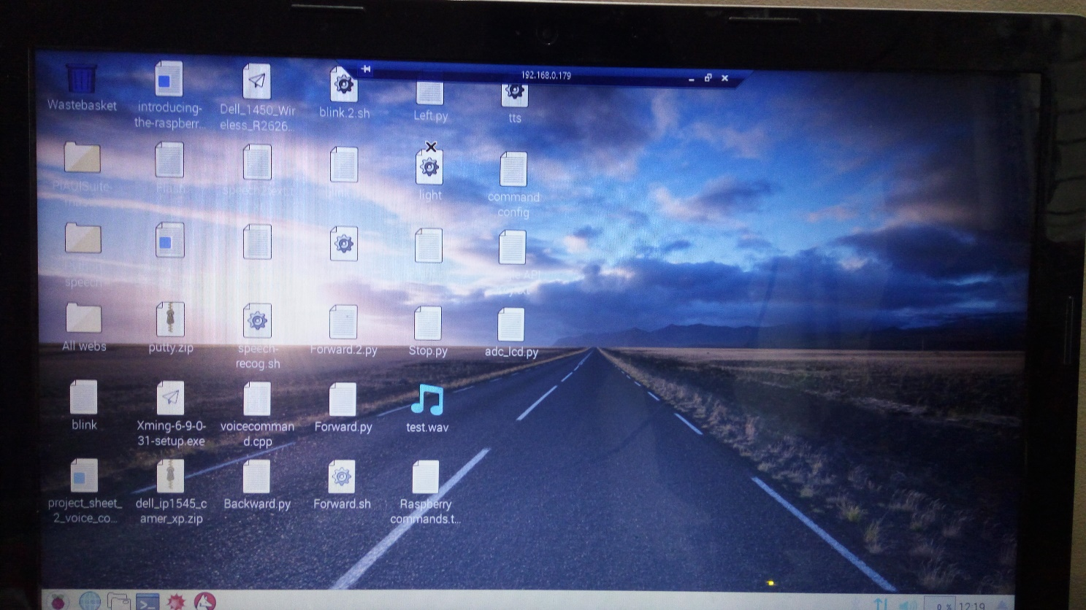

**Fig.(3.5.2) Raspbian Jessie**

Raspbian is a [Debian](https://en.wikipedia.org/wiki/Debian" \o "Debian)-based [computer operating system](https://en.wikipedia.org/wiki/Operating_system) for [Raspberry Pi](https://en.wikipedia.org/wiki/Raspberry_Pi). It is now officially provided by the [Raspberry Pi Foundation](https://en.wikipedia.org/wiki/Raspberry_Pi_Foundation), as the primary operating system for the family of Raspberry Pi [single-board computers](https://en.wikipedia.org/wiki/Single-board_computers). Raspbian was created by Mike Thompson and Peter Green as an independent project. The initial build was completed in June 2012. The operating system is still under active development. Raspbian is highly optimized for the Raspberry Pi line's low-performance [ARM](https://en.wikipedia.org/wiki/ARM_architecture) CPUs.

Raspbian uses PIXEL, Pi Improved X windows Environment, Lightweight as its main desktop environment as of the latest update. It is composed of a modified [LXDE](https://en.wikipedia.org/wiki/LXDE) desktop environment and the [Openbox](https://en.wikipedia.org/wiki/Openbox" \o "Openbox) stacking window manager with a new theme and few other changes. The distribution is shipped with a copy of computer algebra program [Mathematical](https://en.wikipedia.org/wiki/Wolfram_Mathematica) and a version of [Minecraft](https://en.wikipedia.org/wiki/Minecraft" \o "Minecraft) called Minecraft Pias well as a lightweight version of [Chromium](https://en.wikipedia.org/wiki/Chromium_(web_browser)) as of the latest version.

Raspbian is the Foundation’s official supported operating system. You can install it with [NOOBS](https://www.raspberrypi.org/downloads/noobs/) or download the image below and follow our [installation guide](https://www.raspberrypi.org/documentation/installation/installing-images/README.md). Raspbian comes pre-installed with plenty of software for education, programming and general use. It has Python, Scratch, Sonic Pi, Java, Mathematica and more.

The Raspbian with PIXEL image contained in the ZIP archive is over 4GB in size, which means that these archives use features which are not supported by older unzip tools on some platforms. If you find that the download appears to be corrupt or the file is not unzipping correctly, please try using [7Zip](http://www.7-zip.org/download.html) (Windows) or [The Unarchiver](http://wakaba.c3.cx/s/apps/unarchiver.html) (Macintosh). Both are free of charge and have been tested to unzip the image correctly. [9]

**CHAPTER IV**

**TESTING AND RESULTS**

**Chapter-4**

**Testing and Results**

**4.1 Testing:**

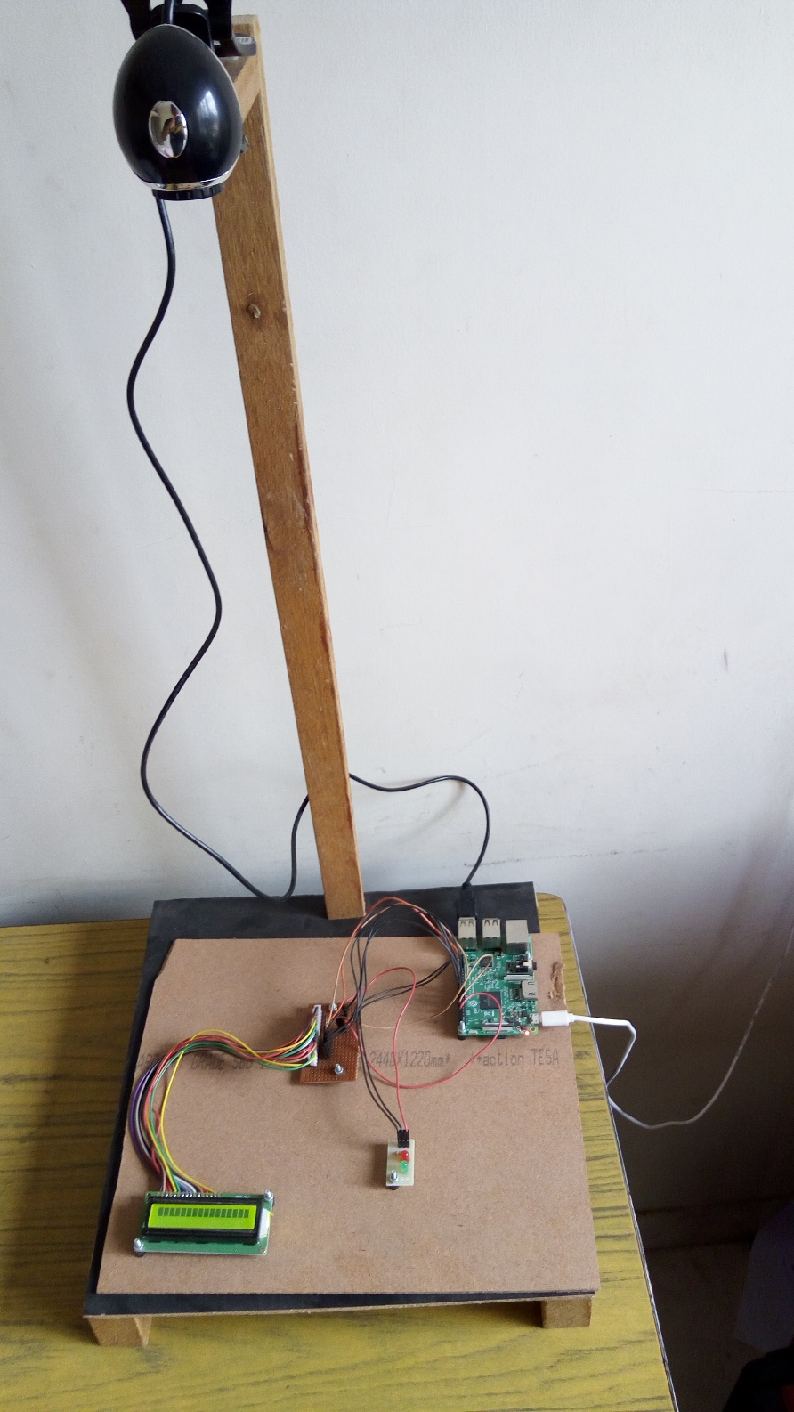

**Fig. (4.1.a) Hardware Testing of the System**

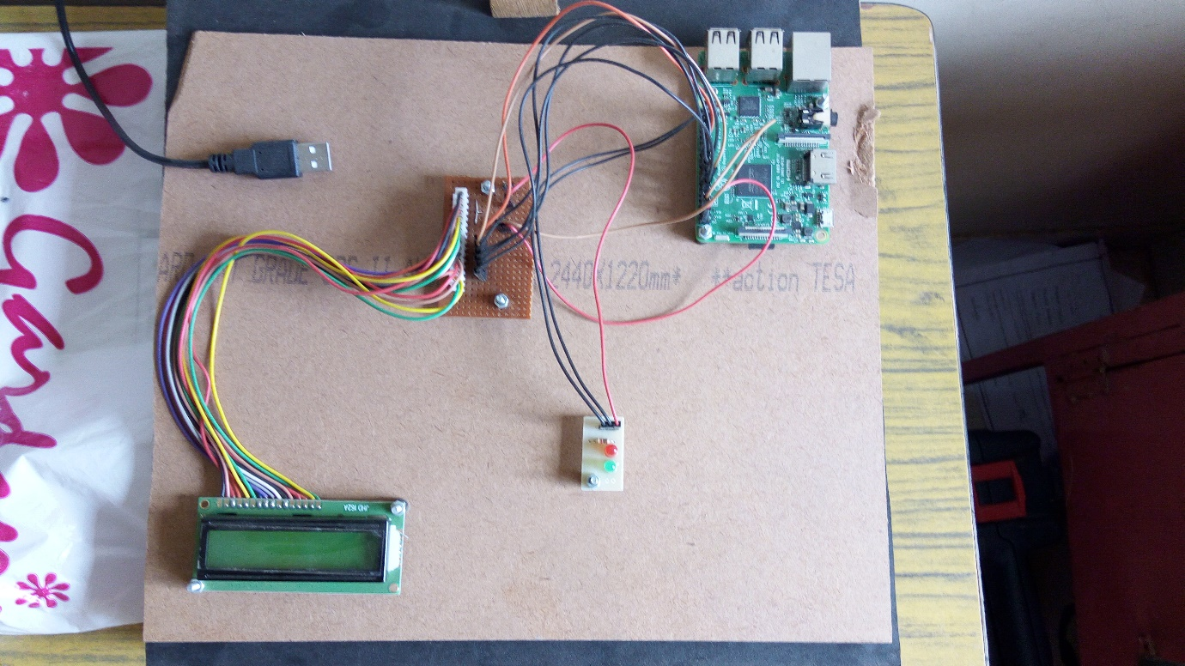

**Fig. (4.1.b) System Configuration**

**Testing of the System:**

* Firstly, the system has been given with an ideal dimensions of the Job to be measured.And specific threshold has been set in the system. (dimensions)
* Since, Raspberry Pi 2 does not have a huge memory, it cannot detect and process multicolour objects which is going to be captured by the web camera device.
* Hence, in this system, blue colour code has been set in the code and accordingly only blue coloured objects are detected and processed.
* Further, a job which here is a blue coloured box is used to test the system.
* 3 Boxes of different dimensions are made to measure over here.
* And accordingly, one of them has the pixel size same as that of the dimensions put as an input to the system.
* And remaining two show error in the dimension which is further indicated with the help of LED’s.

**4.2 PCB Layout:**

Printed Circuit Boards (PCBs) are composed of a variety of complex electrical elements, including resistors, capacitors, diodes, transistors and various other elements. In order for a PCB to function properly, each component must play its part; the result should be a PCB consisting of an array of conductive pathways, etched on copper sheets, which works to mechanically support a larger electronic device. If one component fails, the PCB may fail. Therefore, it’s important that each component be monitored and tested to ensure maximum performance.

The connectivity of each path on PCB was checked using DMM, which concluded the proper etching and soldering of components on PCB. By taking various precautions into account, the PCB Design and soldering of components on PCB was done. The problems faced during the testing are discussed below.

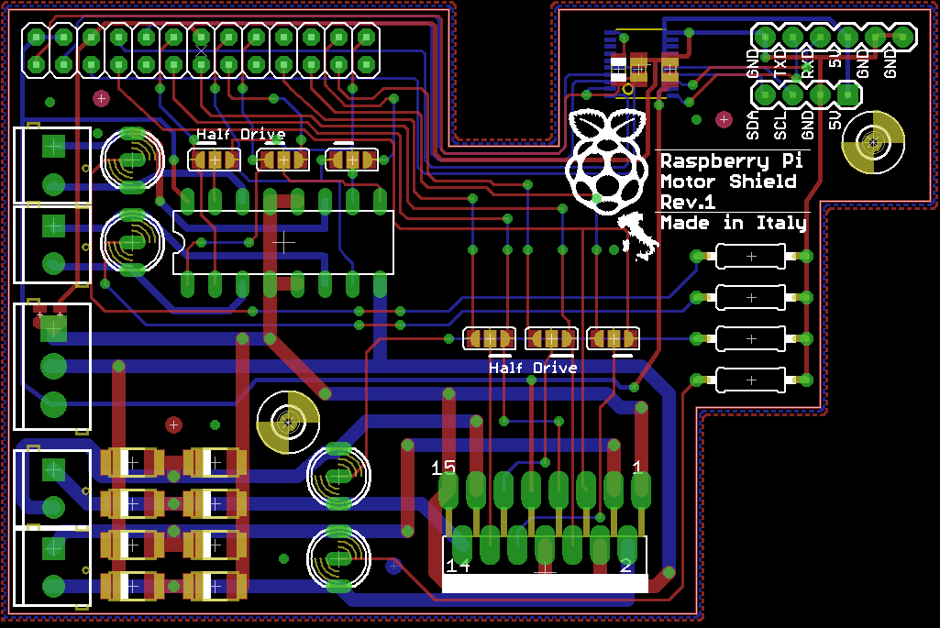

**Fig. (4.2) PCB Layout**

**4.3 Results:**

|  |  |  |  |  |
| --- | --- | --- | --- | --- |
| **Sr. No.** | **Actual Length (inches)** | **Actual Breadth**  **(inches)** | **Observed Length (inches)** | **Observed Breadth**  **(inches)** |
| 1 | 4 | 3 | 3.8 | 2.9 |
| 2 | 3.5 | 3 | 3.3 | 2.8 |
| 3 | 2.5 | 2.5 | 2.4 | 2.4 |

**Table (4.3) Results**

**4.4 Problems Faced during the setup:**

1. Memory required for measuring dimensions of all the colour objects is large.

2. Dimensions of objects can be measured only in 2-Dimensions.

3. The proposed system cannot measure the dimensions of the circular objects.

4. Time required to process the image and display the measurements to detect faults is not ideal.

5. To overcome the above problems, cost required for the project is quite expensive.

**CHAPTER V**

**CONCLUSION & FUTURE SCOPE**

**Chapter-5**

**Conclusion and Future Scope**

**5.1 Conclusion:**

Error Detection using a webcam and a raspberry pi 2 was designed successfully. The data was captured by a webcam and then the information was loaded into a system. Received data was then compared with the master dimensions. After the comparison process, the result were displayed on a 16*2 LCD screen. The correctness was also displayed by two LED’s. Green LED indicated correct dimensions and Red LED indicated incorrect dimensions. Various type of boxes (job) with dimensions can be compared using this system. Main aim which was to measure and detect the correct dimensions of the object was successfully done. This project can be implemented in manufacturing industries.

**5.2 Future Scope:**

This system can be used in all manufacturing Industries. As the error detection is very precise, it plays a pivotal role in mass production. Certainly, this model comes with flaws and it can be figured out in future. On the better half, there are some points listed for future aspect:

* 3-Dimensional Image could help detect errors more precisely.
* Circular Object can be measured.
* Multi- Colour Objects can be measured effectively.
* Powerful Microcontroller can be used to increase internal memory.
* Processing time can be minimised.
* With the use of a GSM software, one can receive the data related to the job on the mobile phone

**REFERENCES:**

|  |  |
| --- | --- |
| [1] | 3D Shape Measurements Using Image Scanner with Multiple White Light Sources by Hiroyuki Ukida and Hiroshi Koretsune |
| [2] | Image Processing on Raspberry in MATLAB by K. Horak, L. Zalud |
| [3] | Remote Monitoring System using Raspberry-pi by Prof. Manasee Patil, Pankaj Soni, Roshan Soni, Swarnim |
| [4] | .  Raspberry Pi- A Small, Powerful, Cost Effective and Efficient Form Factor Computer: A Review by Anand Nayyar, Vikram Puri |
| [5] | EMBEDDED IMAGE CAPTURING SYSTEM USING RASPBERRY PI SYSTEM by G.Senthilkumar, K.Gopalakrishnan , V. Sathish Kumar |
| [6] | SMART IMAGE PROCESSING CCTV CAMERA DEVICE AND METHOD  By Lien-Chieh Shen, Talpei (TW) |
| [7] | Fault Detection in Bearing Using Digital Image Processing by Er. Manju Bala Goel, Er. Karamjeet Singh |
| [8] | www.element14.com |
| [9] | www.raspberrypi.org |
| [10] | <https://in.mathworks.com/discovery/raspberry-pi-programming-matlab-simulink.html> in.mathworks.com |